Experiment 0

:Sensor Calibration and Linear Regression

Name: Jonathan Goh

UID: 404901382

Date Performed: 4/11/18

Lab Section: 9

TA: She, Zhenyu

Partner: Sean McSwain

Homework 0

Question 2 (Disclaimer did work on paper, if this should be changed in the future let me know):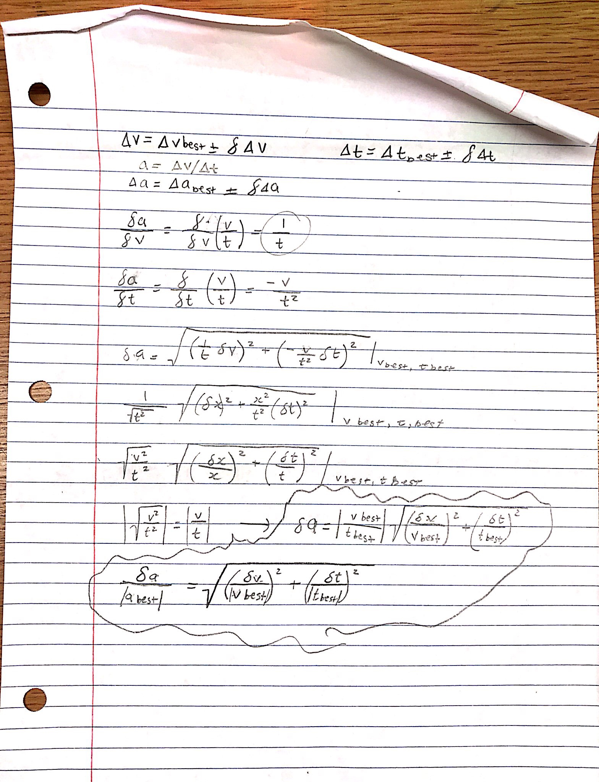

Question 3:

The maximum number of digits that can be displayed is 16 digits.

With a sensor precision of 4 digits, the digits in spots 5 through 10 would be completely meaningless since those would have imaginary values as space fillers.

Turning down the precision to decrease fluctuations in data may seem like a good idea, however, this is not the case if you want to take good measurements. In order to take good data it would be a better idea to keep your precision as high as possible so that your resulting data is as accurate as possible. For some datasets that have extremely small values (i.e. 0.0039999) it would be a very good idea to keep precision as high as possible.

Question 4:

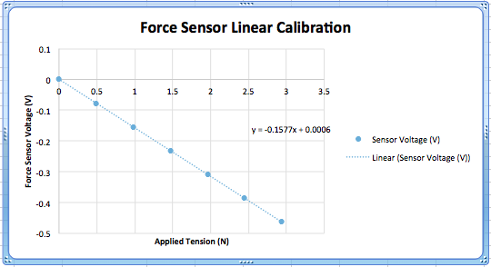

The plot above shows the User-Defined Voltages that were collected from a force sensor that had various attached forces (mass\*gravity).

Question 5:

From the calibration, it was observed that the Force of an object has an inverse (almost linear) relationship with the Force Sensor Voltage. The relationship can be approximated using the equation (V = -0.1577F + 0.0006), or to account for slight deviations/uncertainty the equation (V = [-0.1577 ±0.0001]F + [0.0006±0.0002]). In the equations, y is the Force Sensor Voltages and x is the Force value. The A value (the X Variable coefficient) was calculated to be (-0.1577) mV/N with an uncertainty of (±0.0001) mV/N. The B value (the Y-Intercept) was calculated to be(0.0006) mV with an uncertainty of (±0.0002) mV. Given the regression equations, we can extrapolate/approximate the Force Sensor Voltages of many different masses by plugging in Force values as the variable (F).

As seen through the y-intercept, which has a value of 0.0006±0.0002, the measurement is not exactly zero. Since our y-intercept is slightly off of zero, we can conclude that the taring button does not completely zero-out the sensor when pressed.

Question 6:

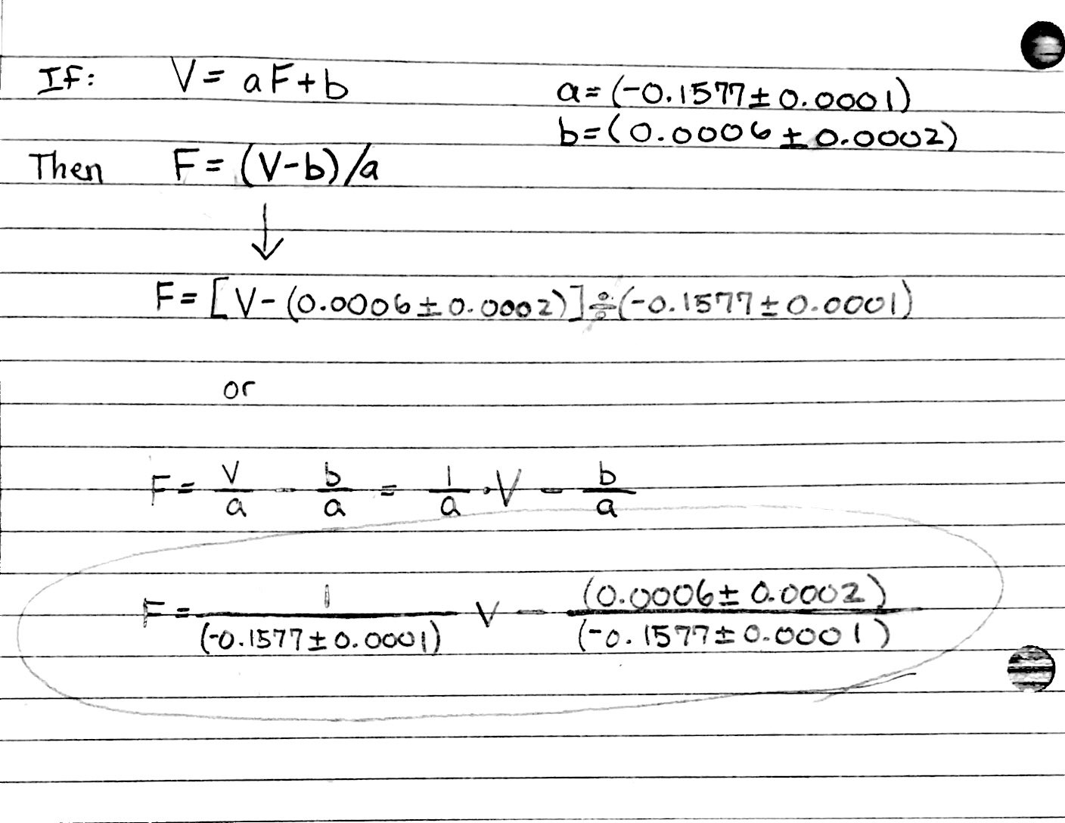

Question 7:

It is possible for 2 students to receive the same raw score for the course but not receive the same letter grade due to the Numerical Grade Normalization that is enforced for Physics 4AL. In the case of Frankie and Avril, we can draw the conclusion that the mean numerical score in Frankie’s class would have been lower than that of Avril’s class. If the mean grade in Frankie’s class was lower than that of Avril’s, then we assume that the TA in Frankie’s class is a harder grader. The premise behind grade normalization is that some TA’s may be harder/easier graders on lab reports; as a result, in order to be fair the course uses grade normalization.